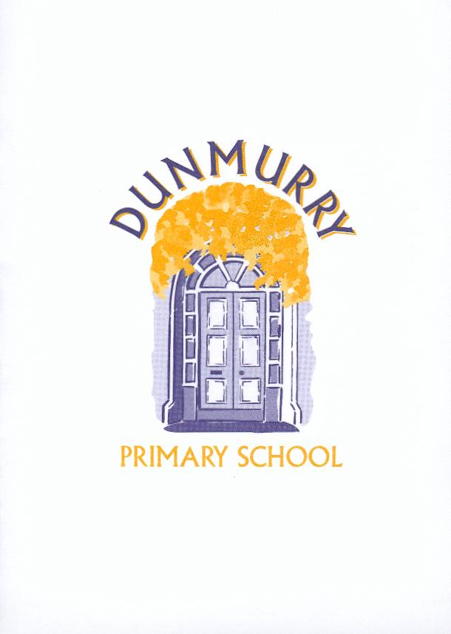
Dunmurry Primary School

Uniform Policy

The Board of Governors and staff of Dunmurry Primary School ask parents to support our uniform policy to encourage a sense of belonging and pride within the pupils.

Girls Boys

School sweatshirt with logo School sweatshirt with logo

White polo shirt White polo shirt
(with or without logo) (with or without logo)

Grey skirt/pinafore Grey trousers

White/Grey/Navy socks/tights Grey/black socks

Black school shoes (no heels) Black school shoes

Summer dress option Grey shorts option in summer

There are other options of a school coat, hat and scarf available. No jewellery for health and safety reasons other than a watch and small studs if ears are pierced. Hair accessories to be small and in school colours.

P.E Uniform

P1 – 3 P4 – 7

Black gym shoes School polo shirt
Black or Navy shorts/tracksuit bottoms
(preferably no leggings please)
Trainers

If your child does not have their P.E. uniform with them they will not be allowed to participate in the lesson.

School Uniform and P.E. Uniforms must be labelled clearly with the child’s name.
The school does not replace lost property items, lost property boxes are kept in the medical rrom.

Uniform Supplier : McCalls of Lisburn, 20-24 Market Street, Lisburn, BT28 1AB.
028 9267 5111 info@mccallsoflisburn.com

