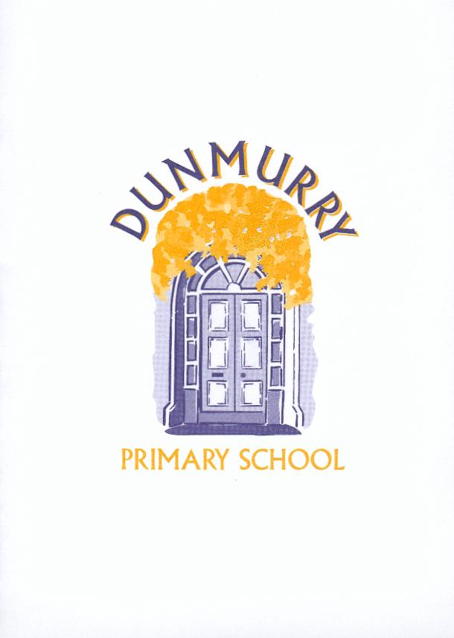

DUNMURRY PRIMARY SCHOOL

ANTI-BULLYING POLICY

In Dunmurry Primary School we believe that a secure and positive environment ensures each child is safe and happy at school to enable them to learn effectively and fulfil his or her full potential at each stage of his or her development.
Dunmurry Primary School has zero-tolerance for bullying.

The Aims of the Policy

- To reflect the school’s core aims in maintaining a safe, secure and happy environment for all children and staff.
- To prevent bullying in any form.
- To ensure that all pupils, staff and parents are aware of their responsibilities in relation to bullying.
- To ensure we have strategies and a consistent approach to dealing with it.

What is Bullying?

The ‘Address Bullying in Schools Act (NI) 2016’ gives this definition of bullying;
“Bullying” includes (but is not limited to*) the repeated use of:
- any verbal, written or electronic communication
- any other act, or
- any combination of those,
by a pupil or group of pupils with the intention of causing physical or emotional harm to that pupil or group of pupils.
“act” includes omission.

“Bullying” refers to a range of harmful behaviour, both physical and psychological – which is usually:
- Repetitive;
- Persistent;
- Targeted; and
- Intentionally harmful.

The definition identifies 3 core characteristics:
- Non-limitation to repeated behaviours;
- Methods of bullying (including omission); and
- An intention to cause harm. **

Bullying can be:
- Physical – pushing, hitting, kicking, spitting, pinching, threats
- Verbal – name calling, sarcasm, persistent teasing, spreading rumours
- Emotional – exclusion, ridicule, tormenting, coercion
- Social – racial or religious remarks, taunts, gestures
- Cyber – bullying

*’not limited to’ within the legal definition gives the school the legal support to deal with a serious one-off incident, which causes significant emotional harm, and to deem it a “One-off bullying incident”.

To determine if a One-off incident is bullying the following factors will be taken into consideration:
- Severity level and significance of the incident
- Evidence of pre-meditation – planning and preparation involved
- Impact of the incident on individual/s (physical/emotional)
- Impact of the incident on the wider school community
- Previous relationships between those involved
- Any previous incidents involving the individuals.

An incident which does not meet the above criteria will be addressed through the Positive Behaviour Policy.

** What is harm?
Harm can be defined as:
- Emotional or psychological harm such as distress or anxiety caused for example by intentionally scaring, humiliating or affecting a child’s self-esteem
- Physical harm as intentionally hurting a pupils causing injuries such as bruises, broken bones, burns or cuts.

Signs of Bullying

Victims of bullying will often remain silent but may display some of the following behaviours;
- change in behaviour
- withdrawal
- anxiety
- lack of concentration
- marked deterioration in schoolwork
- absenteeism
- unexplained cuts and bruises.

It must also be remembered the bully/bullies themselves may be displaying unusual behaviours and have their own problems.

What can school do?

It is the responsibility of the Board of Governors and school staff to ensure there are measures in place to prevent bullying while:
- on the premises
- under the lawful control of a member of staff
- travelling to or from school during the school term.

This can include;
- promoting good discipline by explaining and reinforcing school and class rules (see positive discipline policy).
- regular praise and reward for children to develop and maintain a sense of self-worth.
- encouraging children to take responsibility for their own behaviour to increase independence and self-discipline.
- teaching the PDMU curriculum in all classes.
- discussions through Circle Time.
- highlighting the issues involved in bullying and how to deal with them in anti-bullying weeks in school.

We require teaching and non-teaching staff:

- To be role models in word and action at all times.
- To be observant of signs of distress or suspected incidents of bullying.
- To make efforts to remove occasions for bullying by active patrolling during supervision duty.
- To take steps to help victims and to remove sources of distress without placing victims at further risk.

We require pupils:

- To follow school and class rules.
- To avoid any behaviour which could be considered bullying.
- To inform either a member of staff or parent if they know another child is being bullied.

We require parents:

- To support the schools’ Positive Discipline Policy and ensure their children behaviour appropriately.
- To inform the school if bullying is suspected.
- To advise children to tell a staff member about any incidents.
- To work in partnership with the school and actively support the schools’ Anti-bullying Policy.

Procedures for dealing with Bullying

We take the problem of bullying seriously therefore any incidents will be dealt with accordingly.

Criteria for Assessing Bullying Behaviour
Socially unacceptable behaviour becomes bullying behaviour when, on the basis of the information gathered, the criteria listed below have been met:
- Is the behaviour intentional?
- Is the behaviour targeted at a specific pupil or group of pupils?
- Is the behaviour repeated?
- Is the behaviour causing physical or emotional harm?

- All cases of bullying or alleged bullying will be immediately recorded by the class teacher in a specified Anti-Bullying Record book. The record will state:
- What appears to be the motivation for the incident
- The methods of bullying as defined in the legal definition
- How the incident was addressed along with the outcome

- The incident will be discussed with the bully and the victim separately.

- If appropriate the information will be passed on to the Vice Principal or Principal. All relevant details will be recorded after any discussion with the bully or victim.

- The parent or guardian of the bully and of the victim will be informed of reported activities.

- Sanctions may be imposed and the assistance of parents will be sought to encourage good behaviour and to help the school to ensure bullying does not reoccur.

- The school may seek advice from outside agencies when deemed appropriate, e.g. Education Welfare Officer, Educational Psychologist or other employees of the Education Authority.

October 2021

